ACT - Servicestelle der österreichischen Übungsfirmen
Version 1.1

Kosovo
2013
SOE.NETBANK
USER’S MANUAL FOR BANKING SOFTWARE
Programmed by Henk Fung
This manual is based on the program for Kosovo. Please update it to your country before you give it to your students or teachers.
Content
1 Login 2
2 Account Details 3
3 Bill payment 3
4 Pending Transactions 5
5 Funds transfer 5
6 Products and Services 6

For further information please contact: gerald.solic@act.at

Login
For login use the following link:
http://kpfcbank.simrise.com/i-bank/

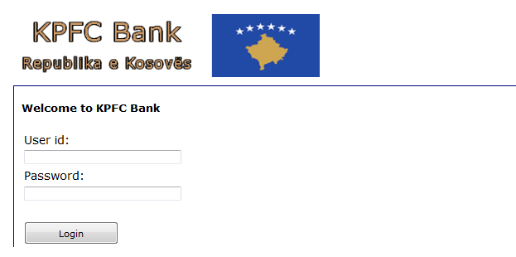
Fill in your User id and your Password, which is given to you from your central office.
(Teachers have special passwords with additional functions e.g. to set up students accounts)
After you have logged in you will see the following screen.
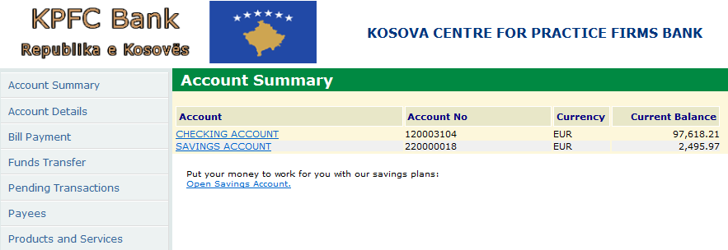
Here you can see your “Account Summary”. In this case, there are 2 accounts, a “Checking Account” and a “Savings Account”. For your work you only need the checking account, which is set up by your central office with an amount of € 100.000,--.

Account Details
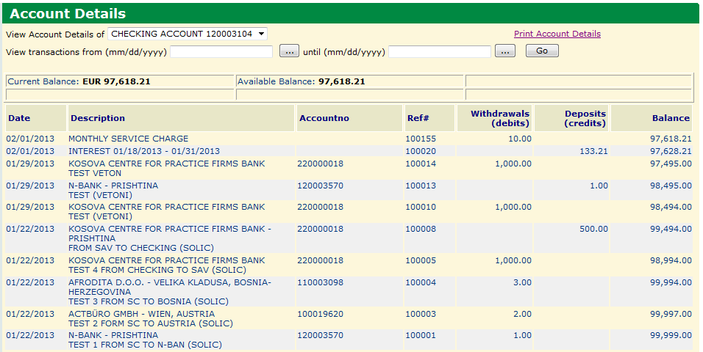
Here you can see all transaction for your account. You also can make a special inquiry for transaction from [date] until [date]. There is also a function to print this page.

Bill payment
Before you can make payments you have to find the payee in the banking program. So you have to go to the link “payees” first.
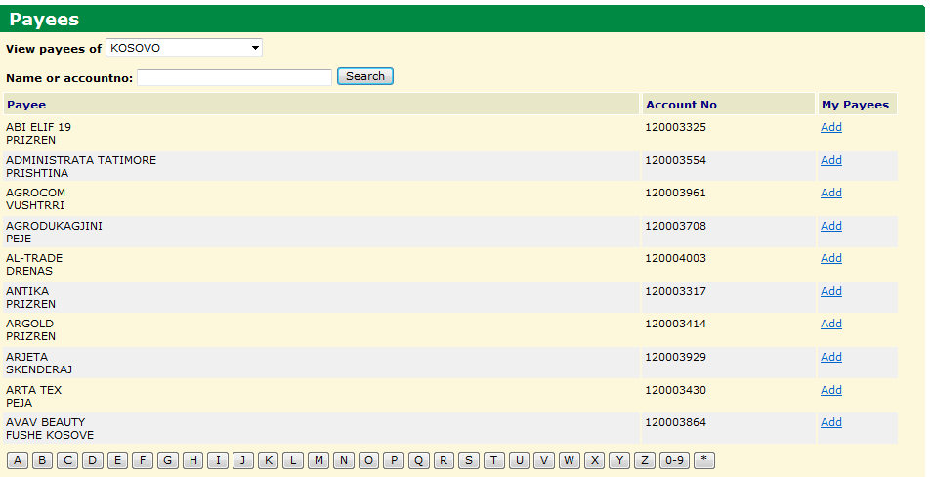
1. Choose the country you want to pay to
2. Search the training firm you want to pay to
3. Click at “add”
After this, the selected training firm is in the list of your payees and you can start with your payment.
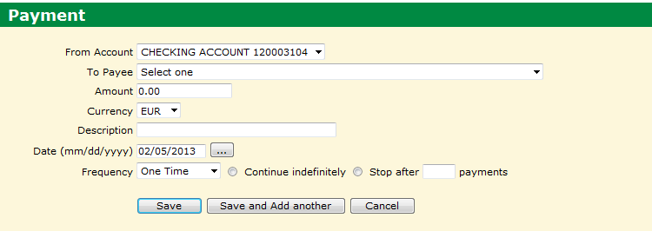
To make a transaction is very easy:
1. Select the payee (here you can find all the payees you added first)
2. Fill in the amount
3. Select currency
4. Give a short description for the payment e. g. number of the bill you have to pay
5. Date
6. Select frequency (One Time, weekly ….) from the list. If you select more than one time, you have to give information how often you want to pay.
7. Click on “Save” or “Save and add another”.
The transaction is now stored in the list of “Pending transactions”. If you want to edit or delete it, you have to click on the link in the main menu on the left side. The “real booking” is done in the night. After this you cannot change it any more.

Pending Transactions
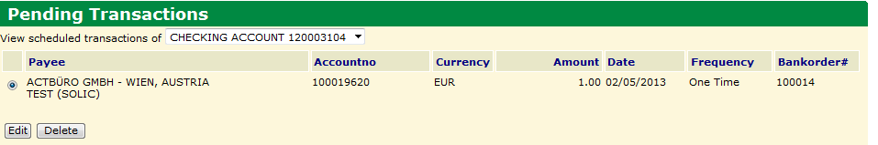
Before the booking is done in the night, you can edit or delete a transaction here.
1. Select the transaction first
2. Click on edit (same mask as payment will appear) or delete.

Funds transfer
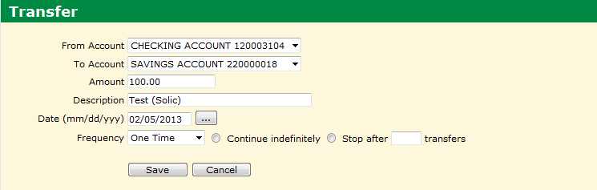
If you have more than one account, you can make transfers from one to another here.
1. Select “from Account”
2. Select “to Account”
….. ( works like a normal payment)

Products and Services
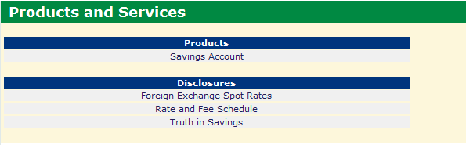

With this function you can open a savings account. There are also special information like foreign exchange rates, rate and fees, and some information about savings.
Before opening a savings account, please read the information “Truth in Savings”.

End of Manuel – I am sure will handle this program without any problem.
Best regards and good luck!
Gerald

